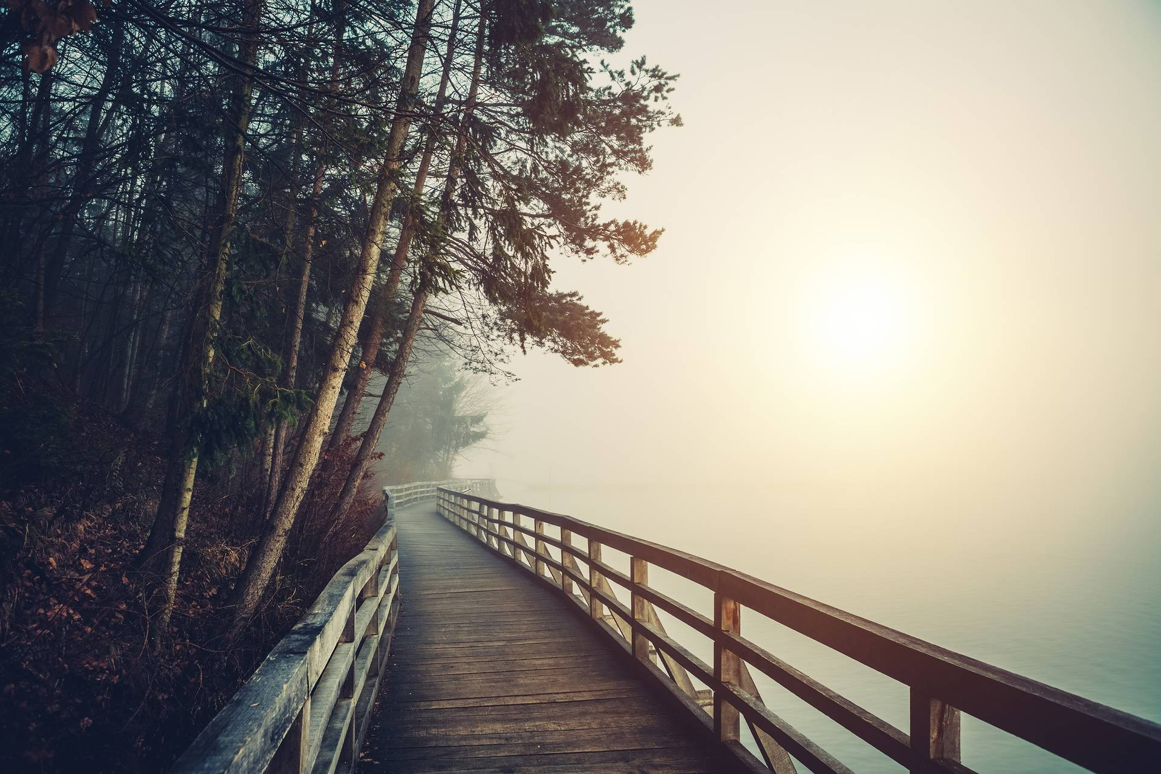
Irrational Entries
Daibik Barik

Acknowledgement
Hey All, a huge thanks to the seniors:
- Anit da (B3)
- Rinkiny Di (B3)
- Ruchira di (B3)
For bringing this opportunity to me to write a story I had planned from ages, but mostly due to the initiative for creating this magazine approach of our “college”. Honestly, I don’t know how you manage your time after all the busy schedules and working you have to do as seniors, but just wanted to let you know that even if it doesn’t go as expected it was whole worth of a try!!
PS:- I know this part won’t be read by anyone else, it was solely just for presentation/ motivation. Hope you like it!

Daibik Barik
2nd Year Student
(+91) 7001760682
bmat2316@isibang.ac.in

Table of Contents
[Chapter 1] — The endless train ride 1
[Chapter 2] — The Echo’s Reply 7
[Chapter 3] — Pictures 8

[Chapter 1] — The endless train ride
The remnants of dusk bathed the platform in a dark golden hue that lingered in the air like memory, slowly fading into encroaching night. Long and thin shadows stretched into the deserted station, accumulating around the edges. Silence marked the world's hush into darkness, until broken by the rustling of leaves and the distant cry of a lonely bird.
The man was standing alone, clutching his bag tight. His shoulders drooped under the weight of another uneventful day and a mind full of thoughts he could not quite unravel. The train schedule had been unclear—no times, no destinations, just the word Departure glowing faintly on an old, cracked signboard. He told himself he would wait for the next train, though he couldn’t say why.
As the golden light dimmed further, a sound like a distant sigh filled the air. The train emerged slowly, as though it had materialized from the fading light itself. Its surface shimmered faintly, catching the last rays of dusk, but the colors seemed to shift—dark green to black, with hints of bronze that vanished when you tried to focus on them. The windows were opaque, offering no glimpse of the interior, and the faint hum it emitted seemed to resonate deep within the man, as though calling to something buried in his soul.
The doors slid open with a soft, deliberate hiss. The man hesitated momentarily, his breath catching in his throat. There was something deeply unfamiliar about the train, yet it felt like it had been waiting for him all along. He glanced back at the empty platform, now draped in shadow, and stepped aboard—not out of logic, but because his instincts told him he must.
#
The man’s gaze wandered across the train car, where passengers sat in silence. Closest to him was an elderly man, his frame hunched and frail. He clutched a pocket watch in trembling hands, winding it repeatedly, though the ticking was faint and irregular. Beside him sat a woman with snow-white hair and tired eyes, her fingers gently stroking the faded edges of a sepia-toned photograph.
Further down, the passengers seemed younger, though their faces bore faint traces of sorrow or longing. A man in his middle years adjusted his glasses as he studied a notebook filled with messy, unfinished sketches. A woman nearby cradled a child’s toy in her lap, her lips moving as though whispering to someone who wasn’t there.
Near the end of the car sat a young couple, their hands intertwined. They spoke softly, their voices inaudible, yet their expressions shifted between hope and trepidation. They seemed unaware of the others around them, lost in their shared moment.
The man noticed how each passenger seemed suspended in time, their presence heavy with meaning yet unknowable. He couldn’t say why, but the sight of them unsettled him. It wasn’t fear, exactly, but an unease that settled in the pit of his stomach. Something about the silence felt too deliberate, the atmosphere too still—as though the train itself was holding its breath.
#
The man’s gaze drifted to the window as the train slipped through the fading golden light. Outside, the world seemed to shift and twist, taking on forms that stirred something deep inside him.
A meadow appeared, soft and golden, the kind that seemed to stretch forever. He recognized it at once—the field where he had spent countless childhood summers. The air shimmered as though carrying the sound of distant laughter, his laughter, echoing faintly before dissolving into silence.
The meadow gave way to the crowded streets of a city. The man’s breath caught in his throat as he saw the familiar café corner where he had once stood nervously, waiting. She was there—her face illuminated by the soft glow of streetlights, smiling in a way that had once made the world feel whole. Before he could fully take her in, the scene shifted, slipping away like sand through his fingers.
Moments blurred together now. The hospital room where his father had lain, pale and fragile; the small house where joy had lived, glowing like a memory only half-remembered; the road not taken, branching out into a shadowy unknown. Each image passed too quickly, leaving behind an ache that was both sharp and tender.
He glanced at the other passengers, each staring silently through their own windows. Their expressions were unreadable, their bodies still as though bound by some unseen force. The elderly man with the pocket watch sat closest, his eyes fixed on a misty landscape where faint figures moved in the distance. The young couple near the back whispered to each other, their faces reflecting shifting skies of vibrant colors and gathering storms.
The man felt the weight of their stillness pressing against his own unease. Were they seeing the same fleeting moments, or was each passenger confined to their own window, their own story? The silence was thick and unbroken, save for the rhythmic sound of the train wheels—a low, steady pulse that seemed to echo in his chest.
And then, the conductor’s voice.
Moving silently through the aisle, the conductor stopped at intervals, muttering phrases under his breath. His words were quiet but repetitive, almost like a chant. “Not yet. Maybe next time. Always moving forward.”
When the conductor reached him, he paused, leaning slightly toward the window. “You’ve crossed your stop,” he said, his voice low, almost regretful. Without waiting for a response, he moved on, his footsteps fading into the stillness.
The man’s heart skipped. Crossed his stop? But where was he supposed to go? The images outside the window blurred, rushing past with relentless speed. The scenery became more chaotic, flickering between flashes of light and shadow, the ground vanishing and reappearing in impossible directions. His breath quickened, each heartbeat thundering in his ears.
He turned to the other passengers, but they were still locked in their silence, eyes fixed on their own shifting realities. The tension coiled tighter around him, a physical weight pressing down as if the very walls of the train were closing in. Time felt broken, stretched thin and ready to snap.
The man’s pulse quickened, his hands gripping the edge of his seat as the train roared into the unknown, carrying him deeper into a mystery that felt as though it would consume him if he didn’t act. But there was no path to follow now—only the dizzying rush of moments past and the sound of the conductor’s words echoing in his mind: You’ve crossed your stop.
#
A man sat there agitated with his heartbeat, as if part of the rhythm of the train beat within him as a drum. The views had slowed down a little, coming from this disorganized blur of moments into something almost recognizable. Before, he felt the pressure ease off; but there was an odd, unnamed feeling left behind.
And when he caught a glimpse of himself in the window glass, he wasn't prepared for the gaze that met him from out of the past: a young-eyed man full of hope. For a fleeting moment, time folded back into a view of the boy who had once held onto his conviction that a world existed waiting for him, full of promise, stories untold.A wave of warmth rushed over him, fleeting yet profound, before the image faded like smoke.
The conductor appeared again, moving silently down the aisle. This time, he paused beside the man, the edge of a smile playing at his lips. “You’ve crossed your stop,” he said, his voice a mix of solemnity and something else—an almost amused knowing. He met the man’s gaze in the reflection. “But sometimes, it’s the journey that matters most.”
The man swallowed hard, the meaning elusive yet resonant. A strange calm washed over him, the tension easing like the last trace of a storm. Yet, the words left an aftertaste of unease, a question that hung in the air.
The conductor stepped away, and the world outside shifted again. The stars had begun to scatter across the darkening sky, cold and brilliant. For a moment, the man was sure he heard the whisper of voices—familiar, yet impossible to place. The air grew heavy with a silent anticipation.
He turned to look at the other passengers, but their faces were now obscured, shadowed by the night. The train continued its journey, and with every passing mile, the realization sank in: he was no longer certain where this path would lead, or if it had an end at all.
#

The train slowed as it approached a station shrouded in a deep twilight glow, a place that seemed both the beginning and end of everything. The platform was bathed in soft gold from fading light and shadows danced across the uneven cobblestones, telling stories of arrivals and departures long past. There was a warmth in the air, a sense of familiarity that made the man's heart tighten, as if he were on the cusp of something both sacred and unsettling.
The passengers stirred, their expressions now different, softened with a kind of recognition that had not been there before. The elderly man with the pocket watch no longer looked distant but met the man’s gaze with eyes that seemed to hold a thousand untold stories. The young couple exchanged glances that spoke of unspoken promises and secrets kept safe. Even the conductor, standing near the door, glanced back with a knowing nod, a smile that spoke of journeys that were only ever half-traveled.
The man’s reflection in the window showed a face that was older, yet somehow lighter—lighter as though some weight had been lifted, but not entirely gone. He looked at the station ahead, its dimly lit sign reading “Home”, a place he hadn’t thought he’d return to, a place he wasn’t sure he should. He felt as if he stood at the edge of a choice, an invisible line drawn between comfort and the unknown.
He turned to look at the others one last time, seeing their faces now carved with the wisdom of shared experiences. There was no longer an air of mystery in their silence; it was something deeper, more resigned. They were here, but they were also elsewhere, part of a story he couldn’t quite decipher.
#
The train came to a halt with a soft shudder, the brakes releasing a low, mournful hiss. The man stood, feeling the weight of both relief and regret. The station before him beckoned, warm and inviting, yet there was a gnawing feeling at the edge of his mind. Was this truly the destination he had sought, or just another place to step into, another version of himself waiting in the wings?
He took a step toward the door, then paused, looking back at the train, the reflections of the passengers merging with the dim light as if to say goodbye. The conductor’s voice, faint and almost playful, echoed one last time: “All journeys end, and some simply pause.”
The man’s fingers hovered over the handle. The station’s familiar glow seemed to promise comfort, stability, a return to what he had known. The thought of stepping out felt like coming home, reconnecting with a past that had once been his entire world. But with that promise came the certainty that the past was just that—gone, unchangeable, like the echoes of voices lost to time. He would find old habits, old faces, and perhaps a life that, though comforting, was also confining, a cycle he had already experienced.
Yet, staying on the train was not without its allure. The uncertainty of the path beyond the station offered something raw and uncharted. The train’s whistle cut through the air, almost like a sigh, promising movement, mystery, and the chance to continue discovering pieces of himself he hadn’t known he’d left behind. But with that path came a deeper solitude, an endless journey where there were no markers, no guarantees—only the perpetual search for meaning in the unknown.
He glanced at the station again, the flickering lights casting long, haunting shadows that seemed to pull him toward what he knew. But he also glanced back at the empty aisle of the train, the fleeting shimmer of untold stories waiting just beyond the next curve in the tracks.
The man took a slow, steadying breath. He knew that both choices had their weight, their rewards, and their costs. To step out into the known, where comfort met familiarity, or to stay, bound to the unpredictable path ahead, where freedom came with its own quiet, lonesome price.
The doors whispered open, and for a moment, the world stood still. The man hesitated, looking at the darkening sky that seemed to promise more than he could understand.
The train's whistle blew again, sharper this time, the doors vibrating as they threatened to shut. Time was slipping away, and the man’s hand, still poised at the handle, wavered. The station's lights shimmered, and the soft murmurs of the passengers faded into the background, as if they, too, were holding their breath.

The doors closed with a quiet finality, and the train eased away from the platform, leaving the station behind, its light growing smaller, then vanishing into the night.

[Chapter 2] — The Echo’s Reply
She shouted into the canyon expecting
the familiar return, a voice of her own,
faint and fading.
“Who am I?” she called, her voice
trembling and the echo
replied, soft, unexpected— “You are
the one who seeks, yet hides.”
Her heart stilled, words caught
in her throat as the silence deepened,
the canyon holding its breath.
“What is it you seek?” The air
grew heavy. The reply came,
a truth she hadn’t wanted—
“Not the answer, but the silence you keep.”
A chill coiled around her concern
tightening like a grip. The next
question lingered, untouched, the space
between her and the echo filled with doubt
and fear. And there she stood,
heart pounding, wondering
if she would dare to speak again.

[Chapter 3] — Pictures

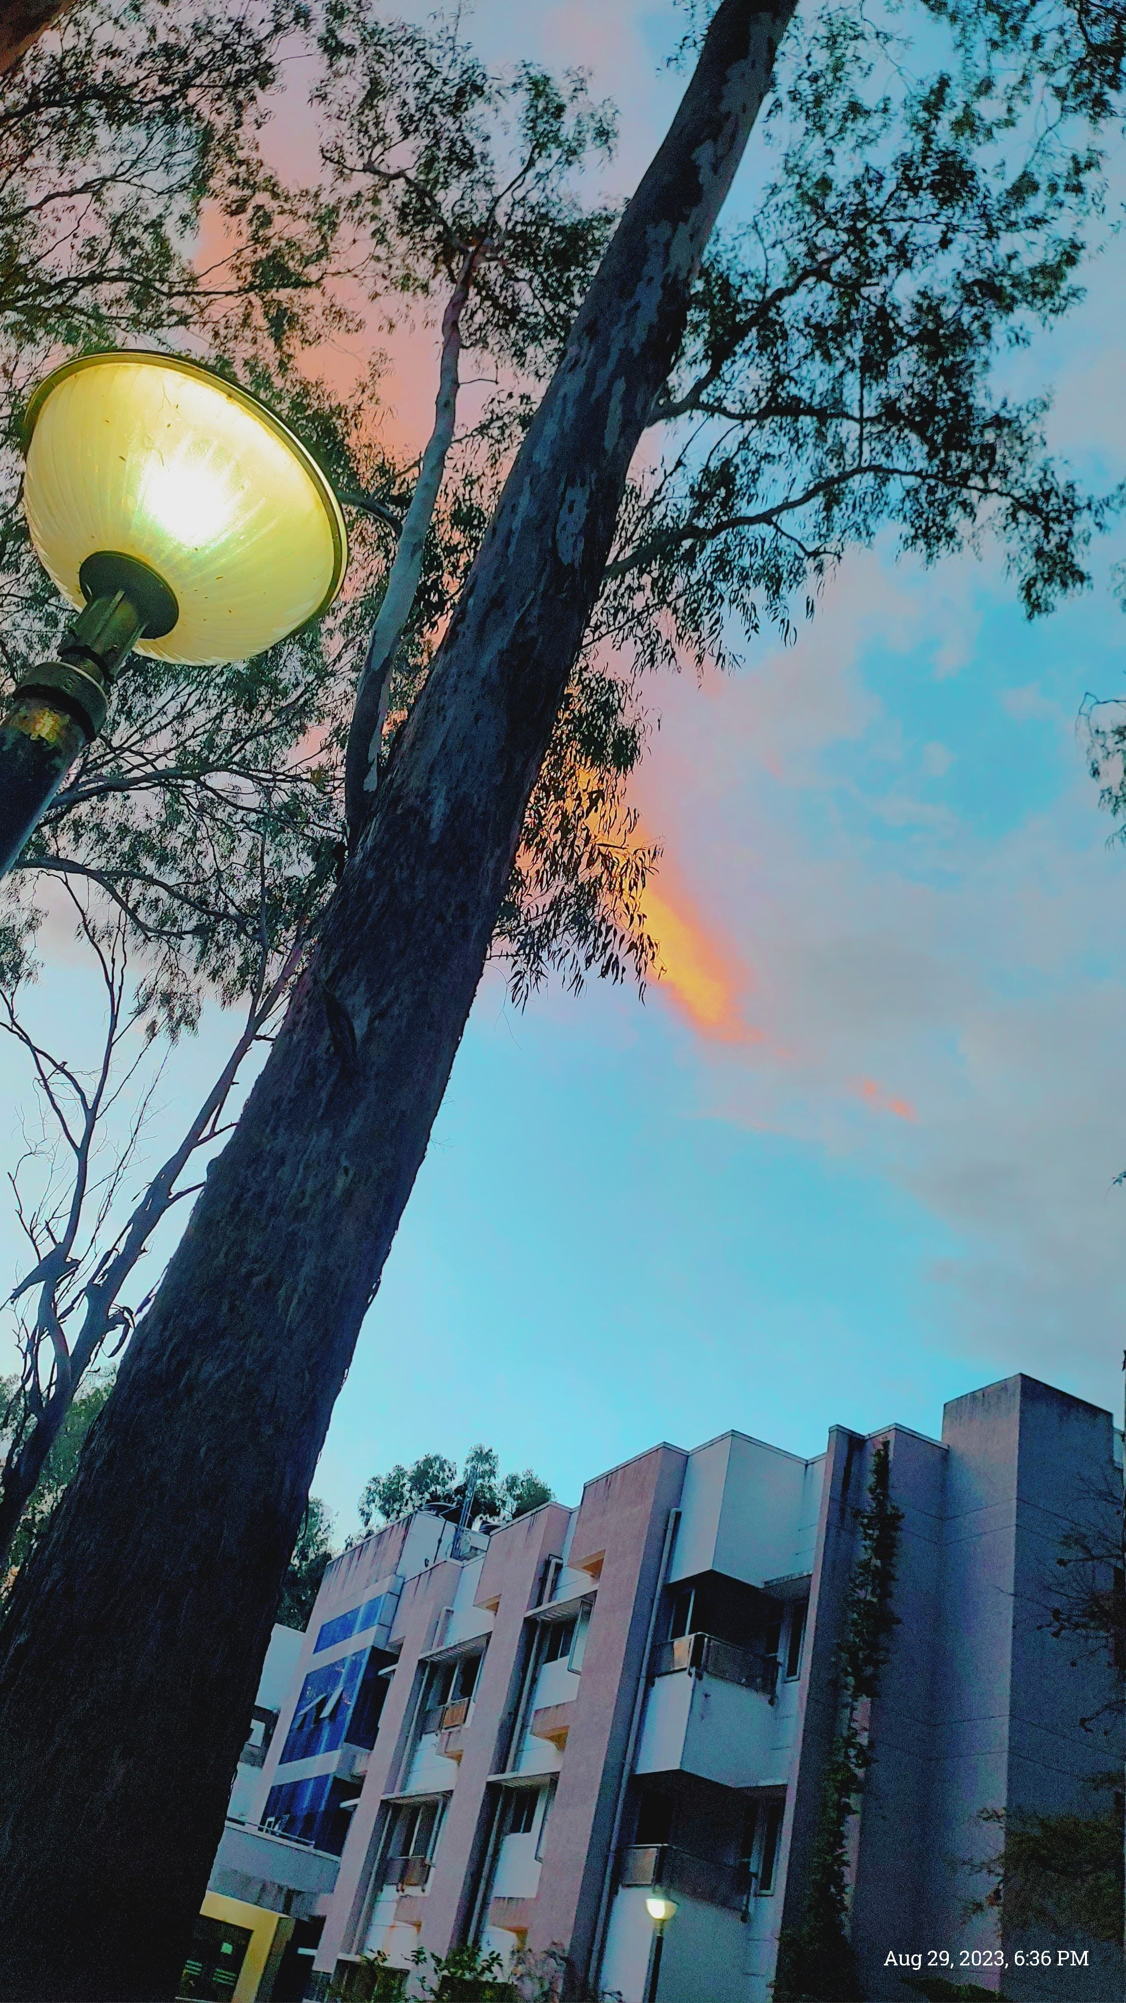

THE END
(This marks the end of the Manuscript)

